|  | | |
| --- | --- | --- |
|  | | **Sitecore Hackathon 2021 – Strikers_Infy** |
|  |  |  |
|  |  | Team: Strikers_Infy  Members:   1. Hemachandhiran Harimoorthy 2. Muttevi Yamini Punyavathi 3. Pavani Gudavalli |
|  |
|  |  |  |

**Response to Request for Proposal**

© 2014 Infosys Limited. Strictly private and confidential. No part of this document should be reproduced or distributed without the prior permission of Infosys Limited.

Table of Contents

1. Introduction 3

1.1 Purpose 3

1.1.1 In Scope 3

1.1.2 Out of Scope 3

2. Pre-requisites needed 4

3. Adding Azure Congnitive Service 5

4. Module Description 7

5. Module Implementation 8

Introduction

## Purpose

The purpose of this document is to provide the usage of the Translator Module developed for the translation of languages enabled for a Site.

This falls in the category of “The best enhancement to the Sitecore Admin (XP) for Content Editors & Marketers”.

### In Scope

This document covers the following areas

* Pre-requisites needed.
* Module Description.
* Module Implementation.

### Out of Scope

This document does not cover

# Pre-requisites needed

1. Sitecore 10.1 to be installed.

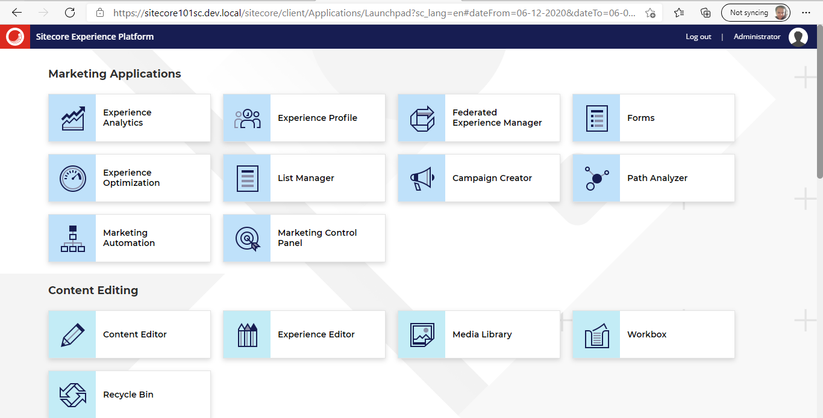

1. The Translator Package included with this project in the Git hub repo.



1. The Languages package included with this project in the git hub repo.



1. Azure Cognitive Services module, API keys for the module

# Adding Azure Cognitive Services

1. Login to <https://portal.azure.com/>
2. Search for Translator in the search bar and select the “Translator” from marketplace

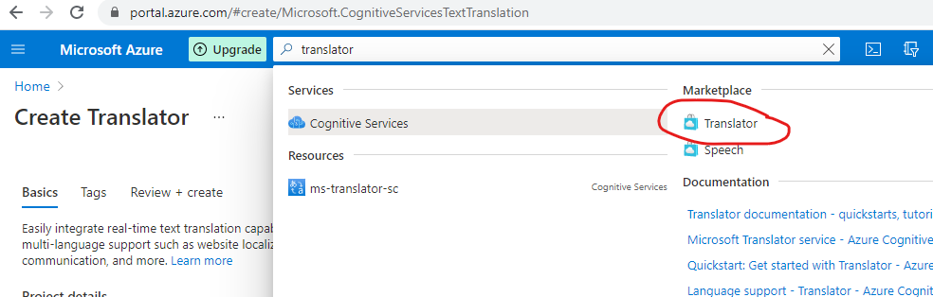

1. Fill out the details and click Review and Finish.

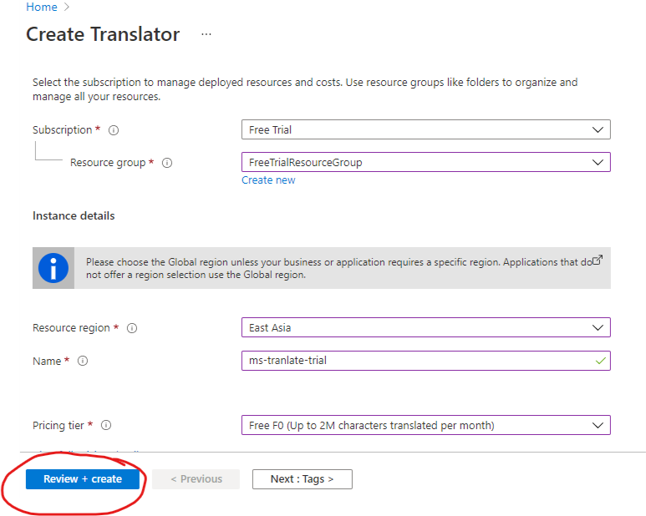

1. Once the service is ready go to the created service and select the “Keys and Endpoint” tab

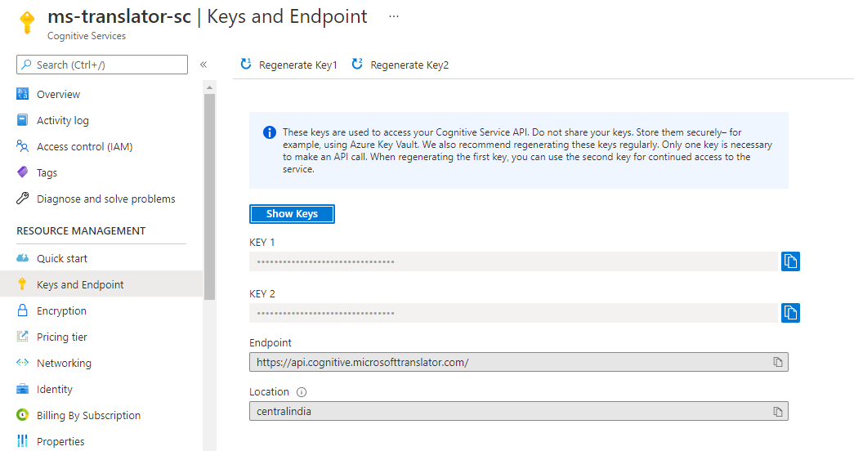

1. Copy the Keys and Location values from here and modify the values in Visual Studio Application
2. Open Visual Studio and open Feature/Translator/ StrikersInfy.Feature.Translator/Biz/ TranslateMgmt.cs file and modify the values

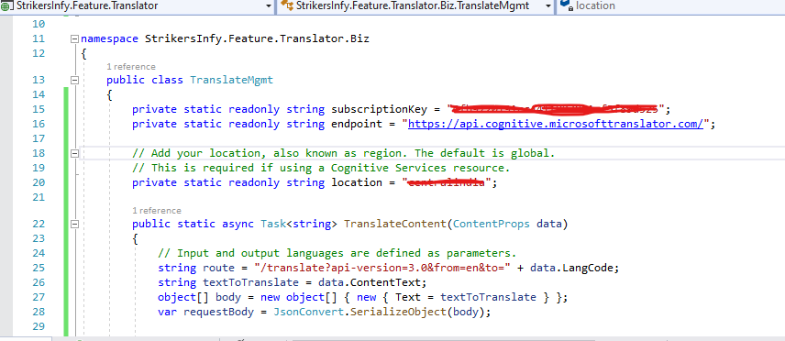

# Module Description

Considering multi-lingual site sitecore Admin or Editors want to create content in different language or marketers are trying to create an email. Provided without inhouse translator the possible way is go to external sites to get the translated data.

With this module Sitecore Admin or Editor need not go to external sites. Within Sitecore they can simply open the translator and translate the data to any languages.

This module used Azure Cognitive Services to translate the data. We are using Free version of the service which provides translation for 2 million words per month. If user requirement is exceeded the limit, we can always change the Pricing tier in Azure.

In the Sitecore Ribbon in versions tab the Translator custom button has been added.

This would enable to output the text in desired language.

**Benefits:**

1. **Quick translation of text in the desired language with in the Sitecore Ribbon.**
2. **Translate text in any number of languages.**
3. **In case of Multilingual, the content editor can simply put the text and translate and update it in the field in the site.**

**Sample screenshot:**

**Input given:**

Ideas for the hackathon:  
- The best enhancement to the Sitecore Admin (XP) for Content Editors & Marketers  
- The best enhancement to SXA  
- Best use of SPE to help Content authors and Marketers  
- Best use of Headless using JSS or .NET

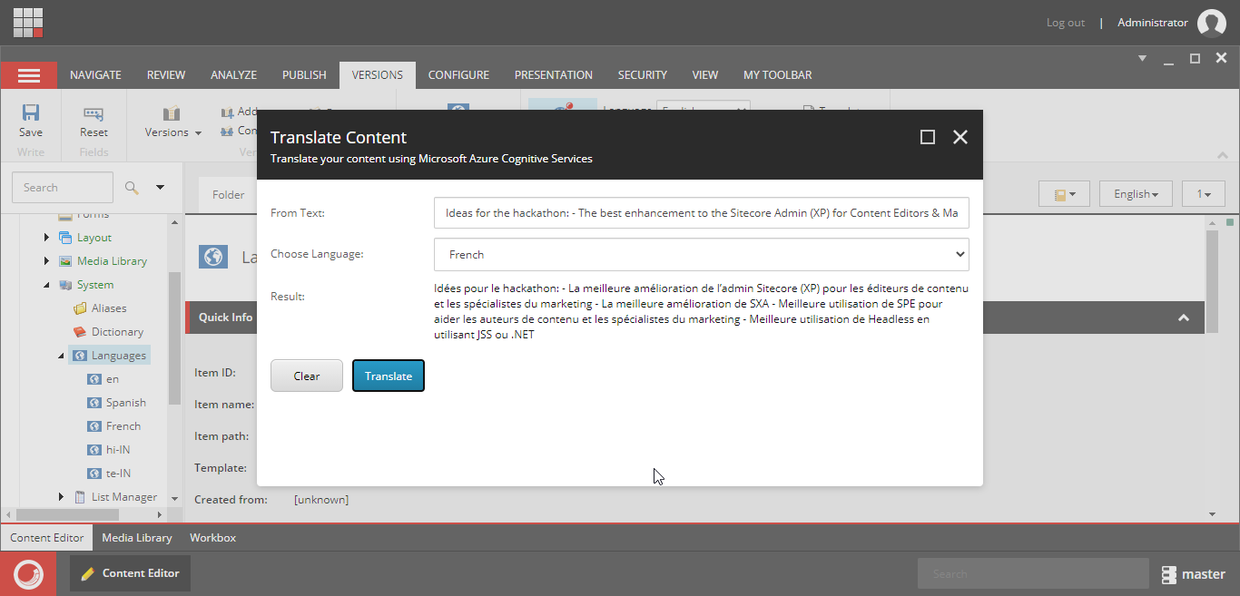

# Module Implementation

1. After the installation of the packages provided in the pre-requisites, navigate to the Sitecore Ribbon -> Versions-> Translator as shown below in which the highlighted is the new feature that appears with the Translator_Pkg_2021_03_06_001 installation.

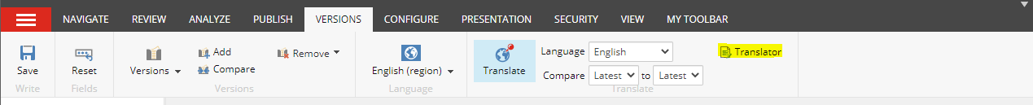

1. With the installation of Languages_Pkg_2021_03_06_001, the default languages Spanish and French would be created as below:

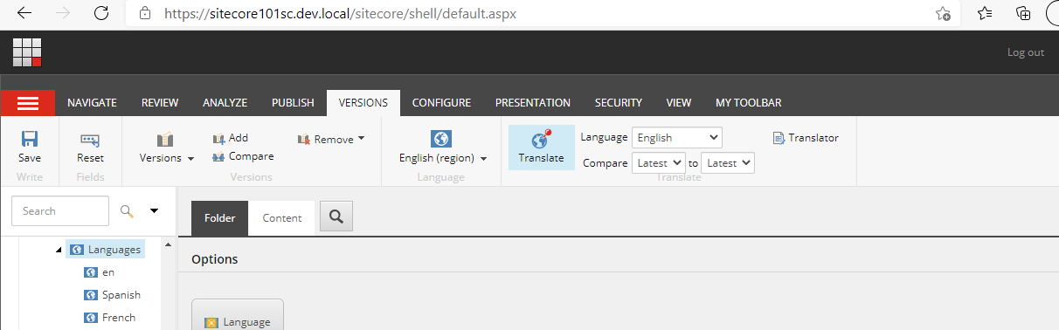

1. Click on Translator, a dialog appears as below:

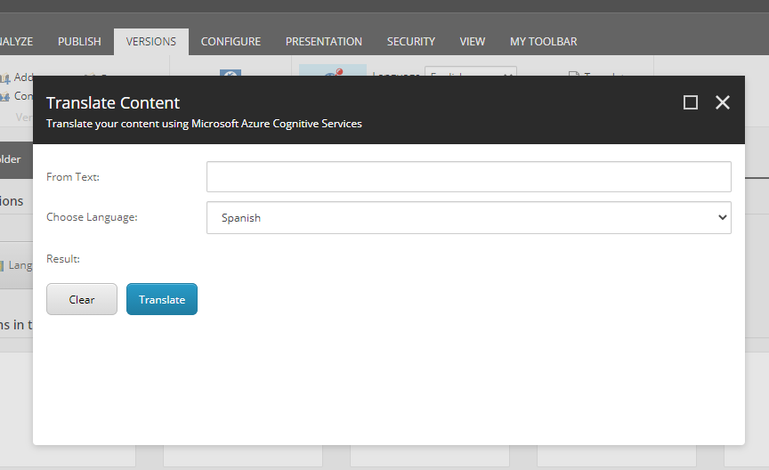

1. Provide the text that is to be translated in “From text” and choose desired language as below:

Sample text: “How are you?”

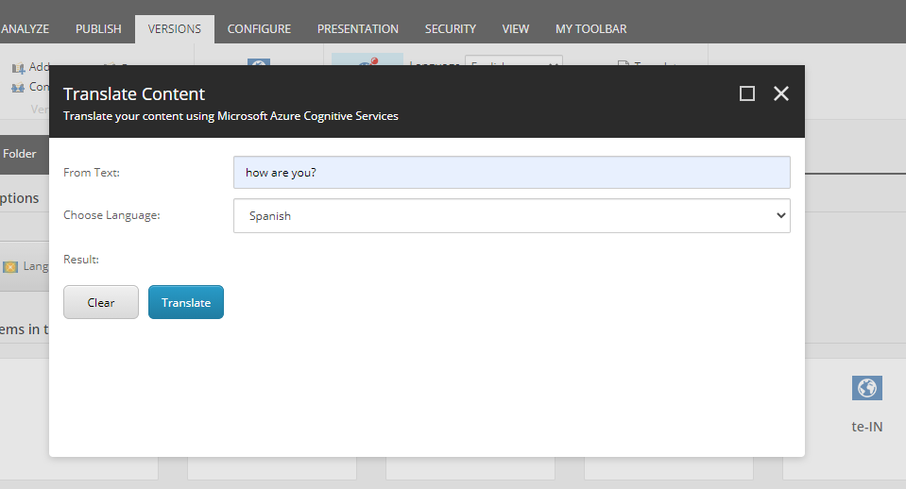

1. Click on the translate button to fetch the desired output as shown below:

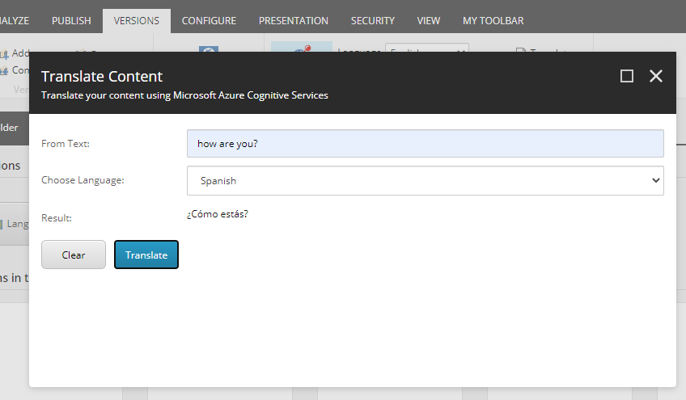

1. For example, the desired language can be added in the path “/sitecore/system/Languages”

Consider the language added as Hindi and Telugu from the list of languages, once they are added in the path **“/sitecore/system/Languages**”**.**

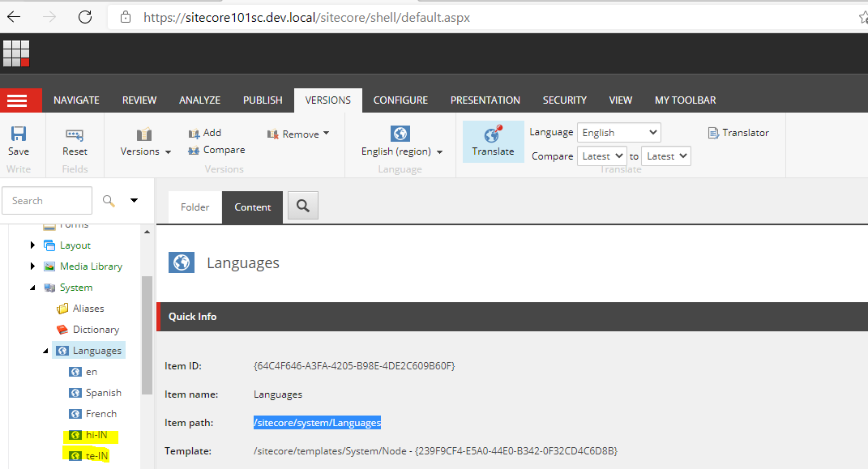

These languages would automatically appear in the drop down in the translator as below:

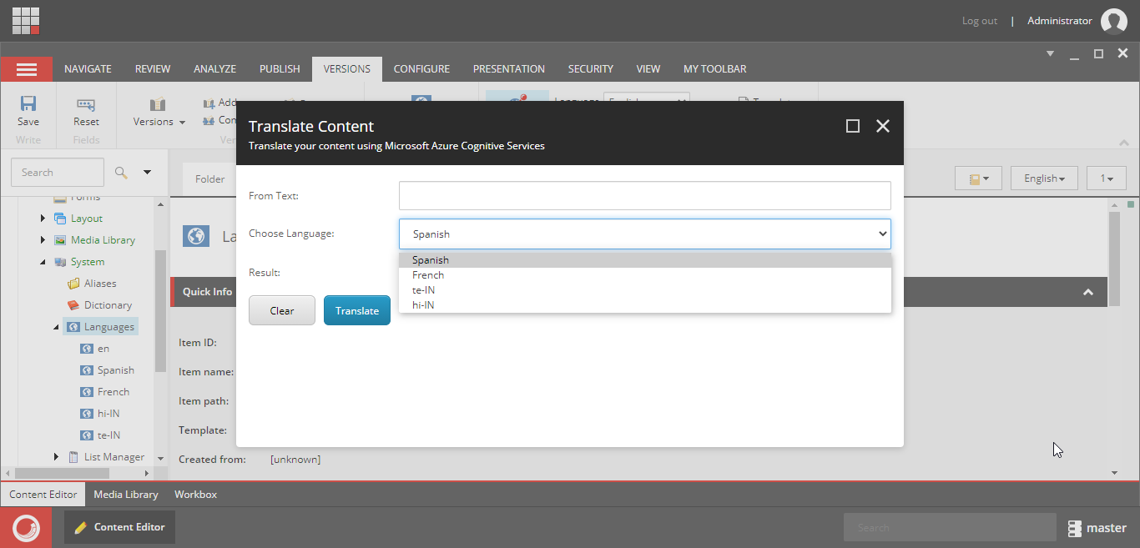

1. Now consider the newly added language in drop down and provide the text to be translated.

Text Given: this is the translation test example.

Output in the desired language.

